**Level Design Document**

Level Design 1920_COMP08092_01

Post Apocalypse

**Team Members**

Conor Haining (B00358028)

Stuart Watt (B00359799)

Mohammed Ibrar (B00348058)

Gabor Juhasz-Hartmann (B00348029)

University of the West of Scotland

Paisley Campus

1. **Design**
   1. Narrative

(Stuart)

* 1. Setting/Theme

1.2.1 Setting

Our game is set in Post-Apocalyptic Boston, Massachusetts in America after a deadly virus has wiped out a large portion of humanity. We have chosen this location due to the wide streets and unique architecture, as we wanted to create an Urban environment that could be both spacious and claustrophobic as players navigate from section to section of the level.

1.2.2 Location

The specific area of Boston this game is exploring is Downtown Boston itself, the reason we specifically chose this is due to the fact we wanted to create an urban environment while still having the opportunity to place wildlife and foliage in places to give a greater sense of nature reclaiming society, we also wanted the player to be able to go through claustrophobic areas like Alleyways and large open areas like parks as we can use this variety in space to create unique and tense moments. The urban area also allows for us to have the players go through buildings and also interact with other survivors as humanity would likely still be condensed in certain areas. We also like this setting as it allows us to make good use of lighting to create a tense and atmospheric setting.

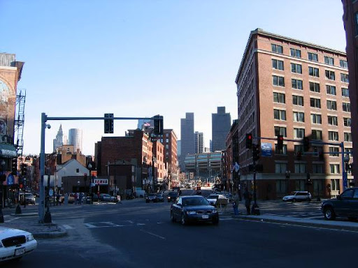

*Screenshot of Boston Streets as location reference*

1.2.3 Theme

The game is set around 10 years in the future, after the collapse of modern society. The level will be set in the evening which means we can use lighting in various ways to create atmosphere for the level, we will also make use of fog to obscure visibility for both the player and AI.

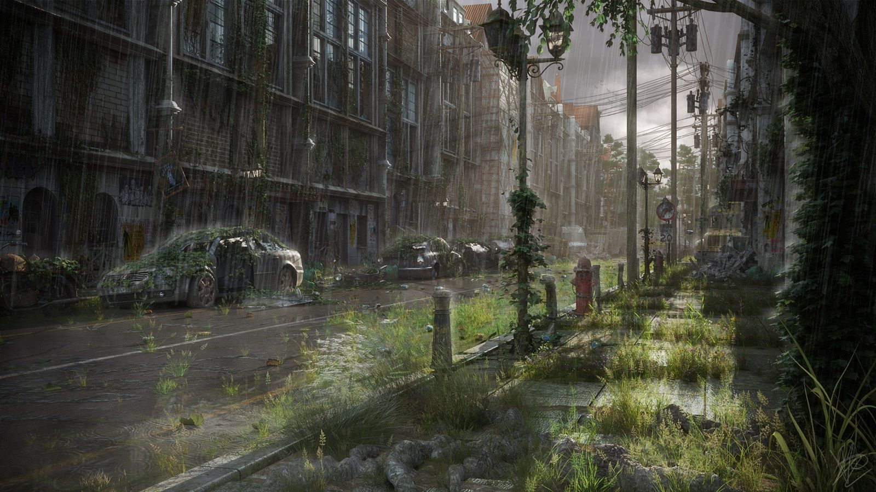

*Post-Apocalyptic Theme reference*

1.2.4 Focal Points

As the player progresses through the level they will have to pass through or by several small ‘Landmarks’ to help guide their progression. The game itself is quite linear in terms of getting from start to finish, but these landmarks will help give the player a better sense of direction and where they are required to go next. Our first major area after the player leaves the alleyway will be a store that the player will need to traverse through, initiating in combat with several AI survivors in order to make it through the building. After making it through this building the next landmark area is a public park where the player will need to find a ladder and place it against a wall on the opposite side of the park in order to progress to our final main area which will be an abandoned factory district. We will place a unique building at the end of the level to signify the player’s final destination, and we will attempt to have this final location visible to the player from the main street the player starts on.

1.2.5 Space

For our game, the space the player has to navigate around the level has been an important focus for us as it is integral to creating an atmospheric and realistic environment for our player to traverse and interact with. We are exploring different uses of verticality in the level so that at times the player may have a height advantage or disadvantage against opponents he faces, and so that everything has a sense of realistic scale within the world.

The player will start the level in a confined alleyway space intended to set the initial atmospheric tone of the game, before moving onto an open street where there will be multiple enemies for the player to either stealth past, or initiate combat with, from there, the player will navigate through an open building with multiple rooms where they will again have to fight off multiple enemies. We are deliberately moving the player from claustrophobic spaces into open ones and then back into claustrophobic spaces to give the player a sense of unease, areas of the level will also be highly dense in objects to provide the player cover, whereas others will be open and therefore more dangerous for the player to traverse across without taking damage.

* 1. Player Experience

As far as player experience is concerned, the overall feeling that we want the player to experience is the feeling of dread, despair along with a sense of nostalgia. As it is set 10 years in the future, the old remnants of what was once a civilised society can immediately be felt by the player and this really puts into perspective the damage that has been caused by the deadly virus. Modern society no longer plays a vital part in the player’s day-to-day life and this is evident in the props used for the level. The player will be determined to reach his destination of the district factory whilst either avoiding the enemy AI and sneaking past them of engaging in direct combat with them. The theme of the level will keep the player motivated as the apocalypse has already begun and survival is the main instinct on the player’s mind, no matter what the cost.

* 1. Level Features

The following is a list of features that the level will incorporate in order to create an interesting and fun experience for any user, and those that will attract the user to return and experience the level again:

* A visually detailed 3D environment created in Unity
* Realistic graphics to resemble the streets of Boston, Massachusetts
* Third person control of the player, with the ability to walk and crouch
* Interaction with the props (e.g. ladder which the player must climb)
* The ability to choose which type of gameplay to experience, for example, stealthily walking by enemies will result in a quieter and stealth-based approach whereas engaging with the enemy will result in a fast-paced action type game
* A wide range of streets, from tight alleyways to open areas
* A sense of realism
* Interaction with an object, without which, the player cannot proceed to the final scene
  1. Design Typology
  2. Gameplay Reference and Research

For our game we have drew inspiration from different mediums of media such as books, games, and movies, from our list of inspirations, these are the titles from each field that we consider most relevant to our game.

**The Last of Us**

The Last of Us is arguably one of the biggest and greatest games created in the entire history of gaming. The game follows the post-apocalyptic story of Joel, a man who has survived through a zombie outbreak and has lost everything to the point of trusting no-one, and Ellie, a young girl who may be the cure to the zombie plague that has fractured mankind to its core. We draw similarities to The Last of Us through our use of urban environments, our post-apocalyptic setting and through the third person perspective we have chosen for our level.

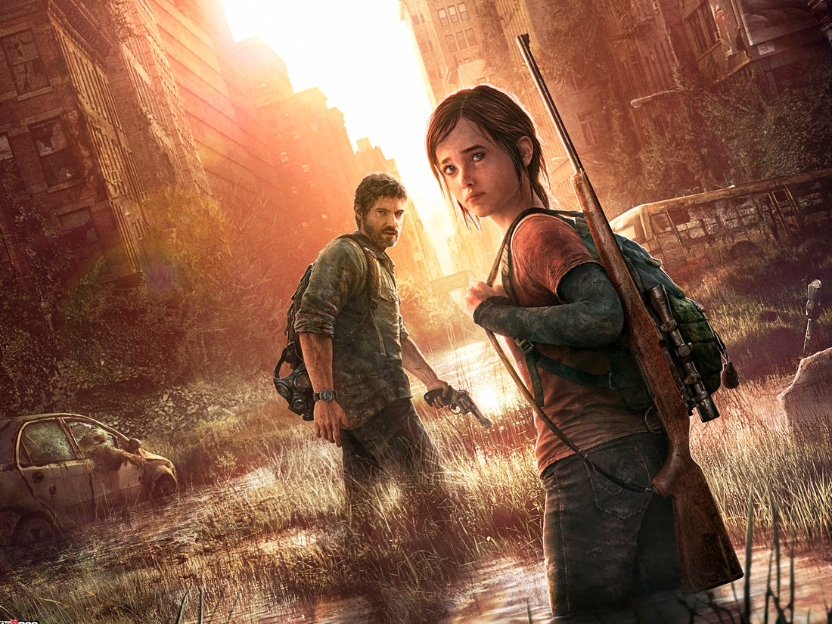

*The Last of Us*

**The Road**

The Road is a post-apocalyptic movie set in America following a man and his son wandering across a post-apocalyptic environment trying to keep civilization alive while trying to avoid roving gangs of savage humans and cannibals. We draw inspiration from this movie due to the post-apocalyptic, dismal and atmospheric setting.



*The Road*

* 1. Photo/Video Reference and Research

1.7.1 Architecture

The level is set in North America, specifically Boston, Massachusetts, and as such we will aim to stick as close to this as possible. The architecture of Boston is a mix of Colonial-style architecture, Georgian architecture and Federalist architecture, and as such there is a large mix of older high-rise buildings consisting mainly of grey or brown brick, and some more modern architecture with glass panelling. Some of the older buildings feature Greek style pillars as a feature of their architecture.

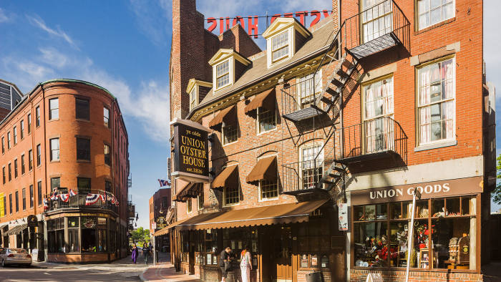

*Boston Architecture Reference*

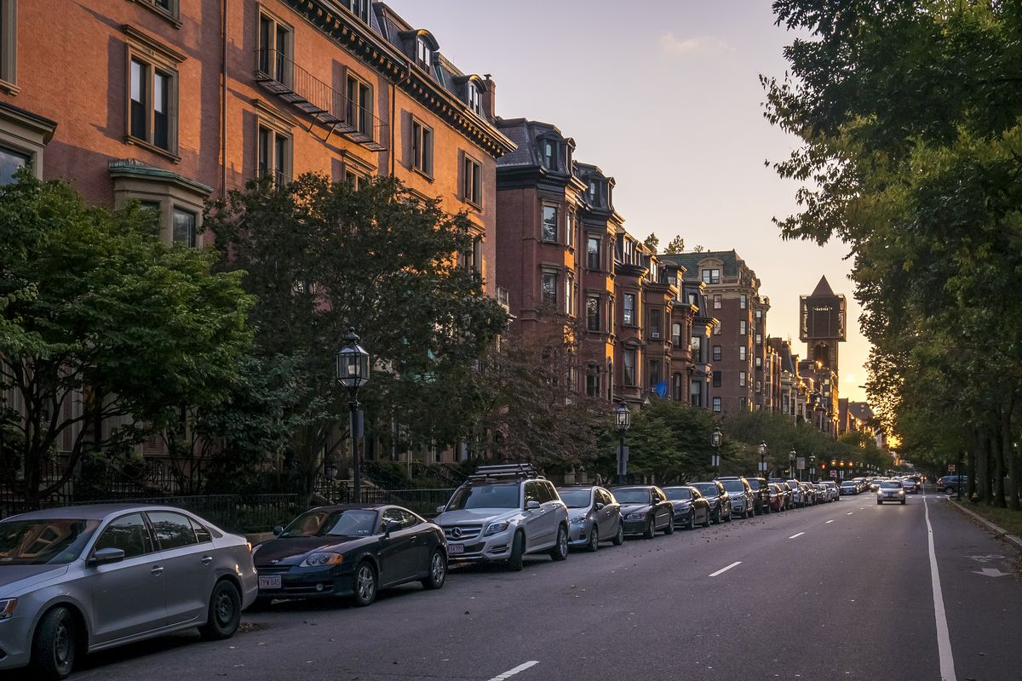

*Boston Architecture Reference*

1.7.2. Props

For this level we will be using props that you would mostly find readily available

in an urban environment to keep a sense of immersion and realism, they will also be used to give the player cover in certain situations along with filling out the otherwise empty locations with a variety of objects to add depth and interest to the level. Some of the objects that we will use is as follows:

* Construction Equipment
* Crates and Barrels
* Rubble from Bricks and Trash
* General litter such as Newspapers and Cans

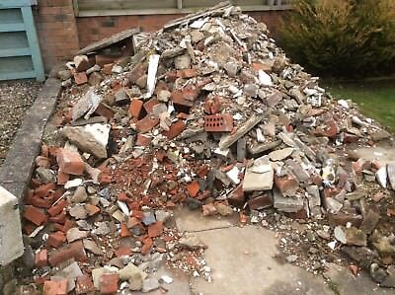

*Rubble Prop Reference*

* 1. Story

(Stuart)

* 1. Interactivity
* Objectives
* Obstacles
* Set Pieces/Scripted Events

(Stuart)

* 1. Visual Development
* Style Reference
* Colour Palette
* Lighting

(Stuart)

* 1. Top-Down Layout and Concept Art

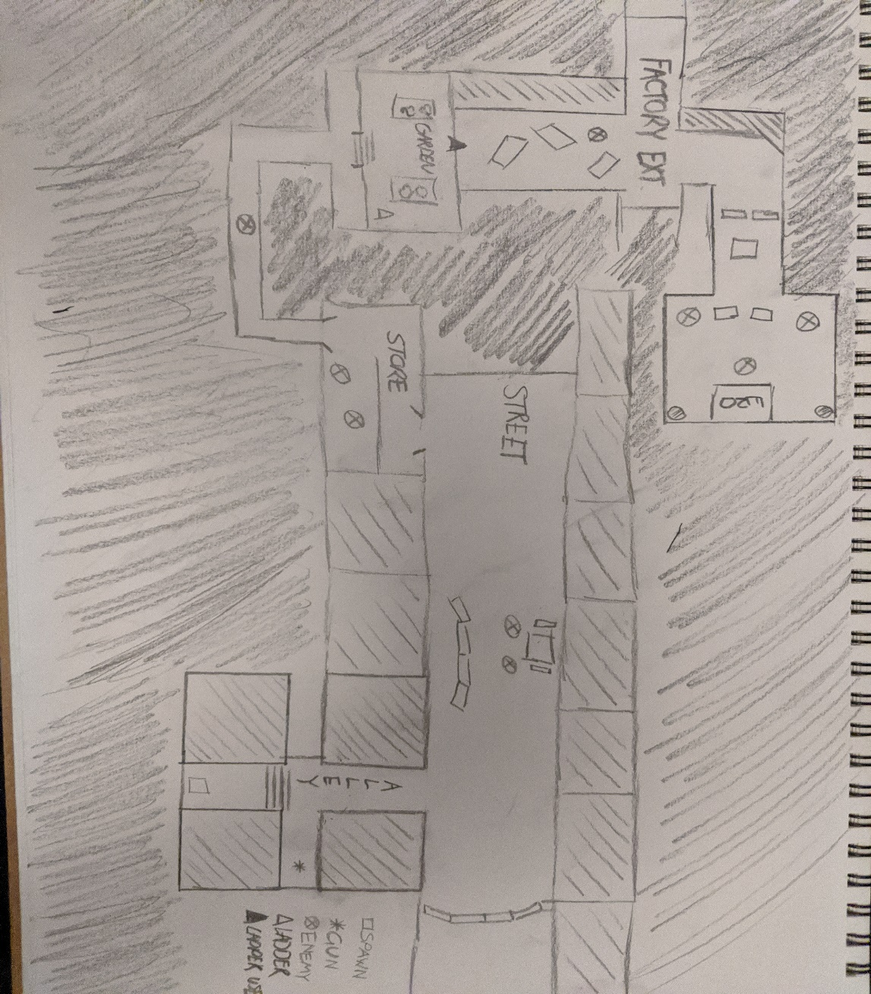

*Top-Down View of Map*

The top-down schematic drawing of the level has been produced in order to visualise what the level is going to look like. From this, we can get a clear image of the playable level and its’ functionalities. This shows the street which the player will walk upon including any props and dead-ends that the player might run into. It also shows other features of the level such as a store and garden, and also an exit point. A key has been included to indicate the player’s spawn point, a gun, the enemy and the upper section of the level where the player will ultimately end up in order to complete the level.

* 1. Uniqueness/Originality of Level

(Gabor)

1. **Project Planning and Control**
   1. Project Plan

For the project plan, the 4 group members of this team kept in touch via Discord. This was set up on day 1 of the class when the assignment was handed out. This allowed us to communicate and allocate tasks regarding the project. In order to work efficiently, and to meet the set deadlines we got to work straight away and planned our level. We had decided that the tasks would be split up as follows:

|  |  |
| --- | --- |
| **Team Member** | **Tasks** |
| Conor Haining | Creating exterior for the level, utilising the use of assets to create the environment |
| Mohammed Ibrar | Working on the blueprint for the movement and shooting |
| Stuart Watt | Working on the interaction functionality with the ladder and AI |
| Gabor Juhasz-Hartmann | Creating the interior for the level, utilising the use of assets to create the interior. |
| Everyone | Documentation |

* 1. Estimated Duration
  2. Tasks and Sub-Tasks
  3. Allocation of Tasks <C>
  4. Progress Monitoring

In order to ensure,

* 1. Version Control <C>

1. **Playtesting**